Page 1 of 2

January 2012

PRODUCT SPECIFICATION

PRODUCT: CHICKEN 3MM WHITE BAADER MEAT

SOLD: CATCH WEIGHT

PRODUCT SPECIFICATION:

Chicken 3mm Light Meat is processed from Chicken breast trim and wishbones within a maximum period of : kill + 3days.

OUTLINE OF THE PRODUCTION PROCESS:

- All raw material intakes are identified by the Plant Number of supply to assist trace-ability.
- Dolavs of raw material are inspected upon arrival to ensure the product complies with temperature and additional internal specifications.
- The raw material is stored at -1ºC to +4ºC until required for processing.
- When required for processing the Dolavs are automatically tipped into a holding hopper.
- The raw material is then conveyored, loaded into a pre-screening tray and is visually inspected by a trained operator who removes any foreign bodies and contamination, before going into the machine.
- The meat is automatically weighed into bags to a weight of approximately
10kgs (+/-100 grammes).
- The bags are then placed into metal trays where they are laid out flat, expelling as much air from the bags as possible.
- The trays are then transferred to the blast freezer where the blocks are frozen
(to a temperature of -18ºC in approximately 18 – 24 hours).
- Once frozen, after a temperature check, the blocks are removed form the trays and metal detected to 4mm Ferrous, 4mm Non Ferrous and 8mm Stainless.
- The blocks are then palletised, shrouded and strapped before a label is applied to two opposing sides.
- The pallet is then weighed to give a nett weight before transfer to the cold-store.
- The product is held in the cold-store in loads (Batch Numbers) until it is despatched.
- The pallets are despatched in clean, odour free vehicles, with refrigerators set to -18ºC or -24ºF

BLOCK SPECIFICATIONS:

Block Size: Approximately 560mm x 370mm x 60mm (I x B x H)

PALLET SPECIFICATIONS:

- 100 or 110 blocks per pallet dependant on Customer Specifications
(approx 1.0 or 1.1 tonne of product per pallet).
- Standard pallets (size 1.2m x 1.0m x 0.15m) of a good state of repair are used.
- Palletised blocks should not hang over the pallet and are stacked 20 or 22 layers high
(1.35m and 1.5 metres high respectively-including the pallet).

USE BY SCHEDULE:

Best Before:- 12 Months from date of Production.

page 2 of 2

NUTRITIONAL INFORMATION:

PRODUCT | MOISTURE | FAT | PROTEIN | ASH
Chicken Ground meat | 65% | 16% Average | 19% | 1%

MICROBIOLOGICAL STANDARDS:

T.V.C. Typical <1 x 10⁶ per gm Max 5 x 10⁶ per gm

Coliforms Typical 1000 - 10,000 per gm Max 30,000 per gm

Staphs Typical 500 - 2,000 per gm Max 5,000 per gm

N.B. THESE ARE APPROXIMATE VALUES

Finished products are routinely tested on a monthly basis to ensure compliance to the above Nutritional / Microbiological Standards.

INGREDIENTS DECLARATION:

CHICKEN

Allowances should be made in recipes accordingly to ensure your final product complies with the Food Labelling (Amendment) Regulations 2003 and The Meat Products Regulations 2003.

Please note that this product may contain more than the 15% Fat allowed for Declarable Meat purposes. The whole recipe should be calculated to see if a separate Chicken Fat declaration is necessary taking into account other Chicken Meats that may be present.

Product conforms to EU regulations.

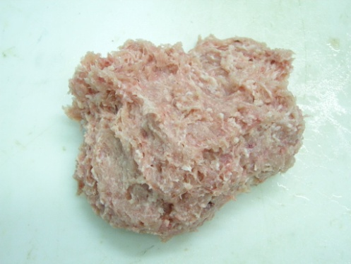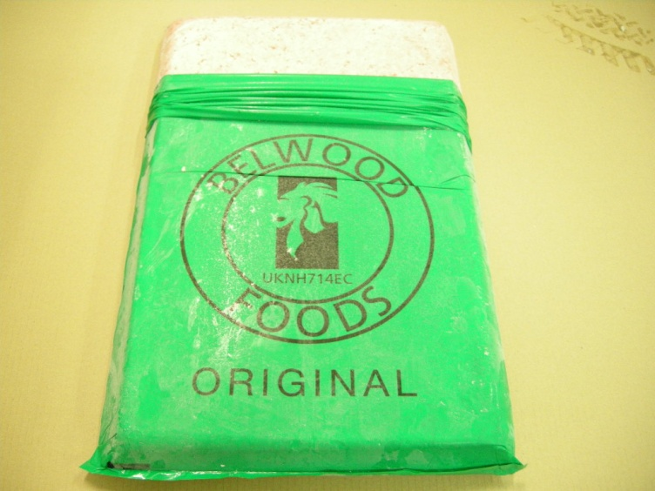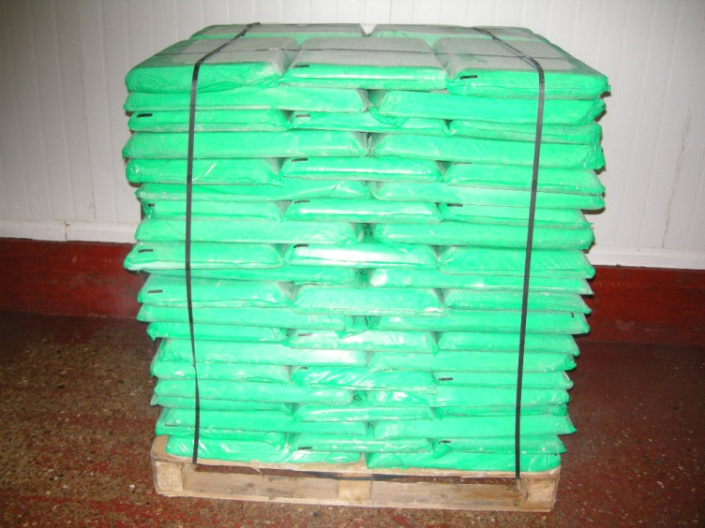

ISSUED BY :- | POSITION HELD | SIGNATURE | DATE
D. FLETCHER | Site Manager

FOR AND ON BEHALF OF CUSTOMER:- (Insert Company Name):-
NAME | POSITION HELD | SIGNATURE | DATE

